Статья опубликована в научно-методическом журнале «Иностранные языки в школе» №3, 2012 г. в рубрике «Из опыта школы».

TRAVELLING

Ключевые слова: traveling, travel quotes, famous travelers, means of traveling, travel agency.
Сведения об авторе:
Барменкова Ольга Ивановна, учитель английского языка, доцент, МАОУ Домодедовская гимназия №5, г. Домодедово. E-mail: mardrew@mail.ru

Коммуникативная компетенция в совокупности ее составляющих по-прежнему является одним из актуальных вопросов современной практической методики преподавания иностранных языков. Предлагаемый материал представляет собой разработку урока английского языка для VIII классf с углубленным изучением английского языка по теме «Путешествие». Данный урок составлен на основе учебника «Английский язык» для школ с углубленным изучением английского языка авторов О.В.Афанасьевой и И.В.Михеевой.
Задачи урока:
- активизация ЛЕ и клишированных фраз по теме в речи, введение новых ЛЕ;
- развитие речевых умений учащихся в разных видах общения;
- развитие логического мышления и умения аргументированного высказывания;
- расширение культурологического кругозора и воспитание интереса к странам изучаемого языка.
Оборудование: магнитофон с записью песни “Holiday Rap” для динамической паузы; видеофрагмент фильма о Лондоне; мультимедийная презентация; буклеты.
Ход урока
- Warm - up (talk about the recent trip to St. Petersburg)
- Teacher: Look at the screen and say what we are going to speak about today (Traveling). Right. First, let’s review topical vocabulary. What are various means of traveling (transport)? You can find help in your textbooks on page 229.

Topical vocabulary
What are the possible equivalents for the Russian word «путешествие»? If you forgot, look at page 232.

A trip – to go on a trip, to take a trip, to have a trip, a business trip, a field trip, a three- day trip
Travel – a general word. Travel agency, travel agent, travel bug.
Journey – a synonym of trip
Voyage – a long journey by sea
Tour – journey for pleasure, professional trips (sightseeing tour, package tour).
By air (by plane, balloon); by bus (by coach), by ship (by boat, ferry, yacht), by train, on foot (camping trip, hitchhiking).
What can balloons be filled with? (gas or heated air).

(Students explain the meaning of the words using the examples)

New vocabulary
Some of the words haven’t been used before. They are: coach, yacht, ferry, hitchhike (say after me together).
Сoach – a bus used for long journeys
Yacht – a large boat with a sail used for pleasure or sport
Ferry – a boat that carries people or goods across the river or a narrow area of water
Hitchhike – travel to place by getting free rides from drivers of passing cars
Why don’t you open your copybooks and put them down? Don’t forget about the date, will you?
Now let’s make sure that your spelling is correct (writing on the board). Good.

3. Teacher: People of all times have liked traveling and written about their impressions. Some wrote serious accounts, while others wrote humorous ones.
Read the travel quotes on the screen and make your comments on the meaning of the quotation, using the words: in my opinion, I believe, I think.
- The World is a book, and those who do not travel read only a page. ~ St. Augustine
- Those who know nothing of foreign languages know nothing of their own. ~ Goethe
- A man travels the world in search of what he needs and returns home to find it. ~ George Moore
- The whole object of travel is not to set foot on foreign land; it is at last to set foot on one's own country as a foreign land. ~ G.K. Chesterton
- To travel is to discover that everyone is wrong about other countries. ~ Aldous Huxley
- The traveller sees what he sees. The tourist sees what he has come to see. ~ G.K. Chesterton

- Teacher: Traveling may mean different things for different people. But there is one thing they have in common: most people travel on holidays, like in the Holiday rap.
Динамическая пауза (исполнение песни).
Holiday rap
We are going to get away
We are going to get away
We are going on holiday
We are going on holiday
We are going to have some fun
We are going to have some fun
In the cold or in the sun
In the cold or in the sun

Britain, Japan, Italy
Which country is it going to be?
We are going down mountains with the skiers,
We are going down mountains with the skiers.
And long canals with gondoliers,
And long canals with gondoliers.
We are going to Venice and Rome,
We are going to Venice and Rome.
And send the postcards back home.
And send the postcards back home.

- Teacher: No matter what we think and say about traveling, a lot of people prefer traveling abroad. Why? For what reasons?
Express your opinions by completing my sentences:
One reason is to…………
Another reason is to…….
Many people travel to………..
Some people travel abroad to ……………
Others like traveling to foreign countries to..……..
Athletes go abroad to…………………..
Students go abroad to……………….
After hard work people go abroad to…………
Presidents of companies go abroad on…………
Those who are interested in history and culture go to …

Teacher: Now look at the slide and make a conclusion, offering arguments in favor of this or that reason. Please, mind the logic and do not forget about the introductory and linking words (Students have 2 minutes to think up their short monologues.)

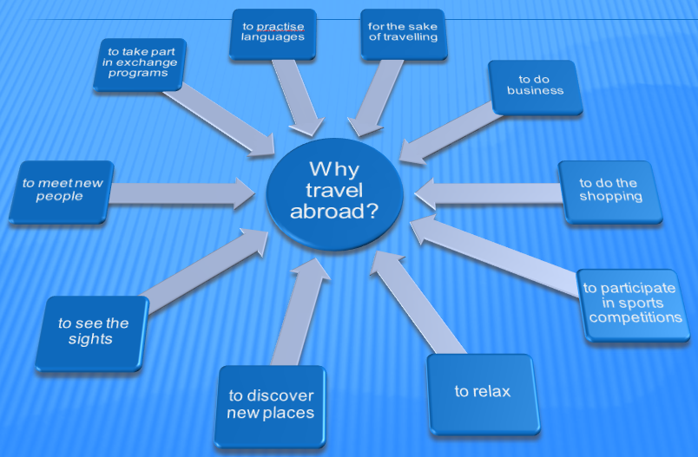
Student’s sample answer:
I’d like to explain why taking part in an exchange program is an important reason for traveling. “We live in a global village” is a well-known phrase today. This means that people want to know more about each other’s culture and way of life and be friends. Learning different languages has become a necessity. For this reason, exchange programs like FLEX, for example have become so popular. That’s why students choose to travel for long distances to find themselves in a completely different environment and practise the language with the native speakers. Besides, host families often offer them interesting trips to show the landmarks of the country. So, traveling acquaints you with the world.

Teacher: And which of these reasons can motivate your journey in your native country? (topical web)

6.Teacher: Well, now when you know why you travel, you need information about the place to go. Where can you find it?
Guide books, travel guides, flyers, leaflets, Internet, personal letters (Slide).
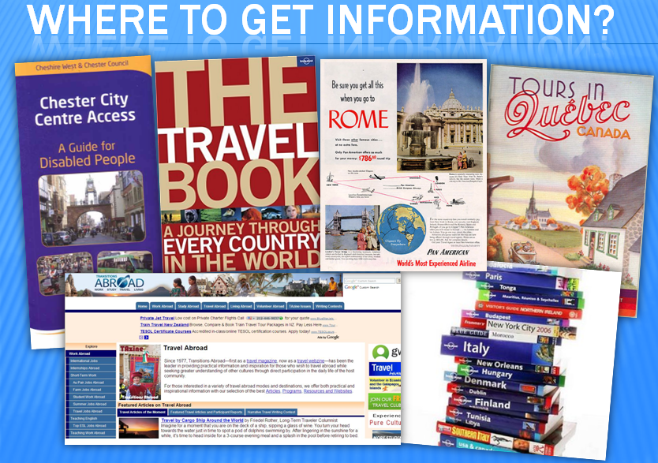

What is the difference? Where can you find more details? What information is more reliable? (Students express their opinions).

Teacher: One more source of information is a Travel agency, isn’t it? Travel agents are usually well-informed. You have to prove it by creating a dialogue “In the travel Agency”. Use the dialogue of the video segment from “BBC Guide to Britain” as an example.
(watching the video, then students are making and practising dialogues at the desks, teacher helps with advice. After that some pairs answer in front of the class using the authentic booklets and pictures).

7.Teacher: Britain is a wonderful country for a visit, but not the only one. Imagine you won a lottery and can afford a group trip. Choose the country for your visit and discuss your plans.
( Students choose different countries: Spain, the USA, Australia, France. Group discussion is organized at the desks).

8.Teacher: Today we have been discussing general things about traveling and traveling overseas for pleasure. But some people were traveling for other reasons. Look at the slide. Are these people tourists? No.

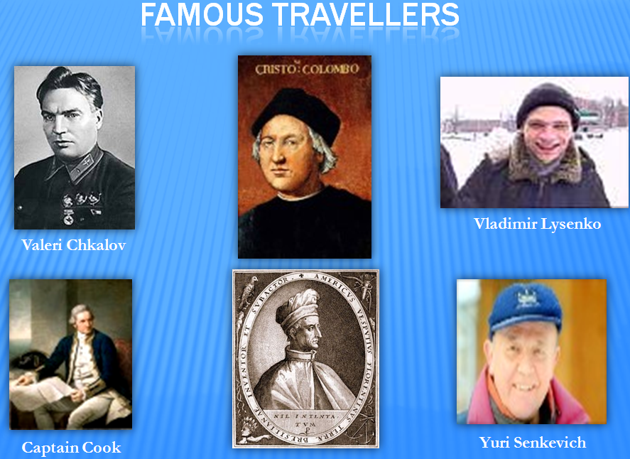

Homework:
1. So, think how to explain the difference between the words “tourist” and “traveler”. Use Longman Dictionary to help you.
2. Make a short report about one of the travelers whose portraits you see or some other traveler, explaining why this person’s name has come down to history.
3. Memorize two quotes about traveling (find them on the board), that you liked, be ready to explain their meaning.

